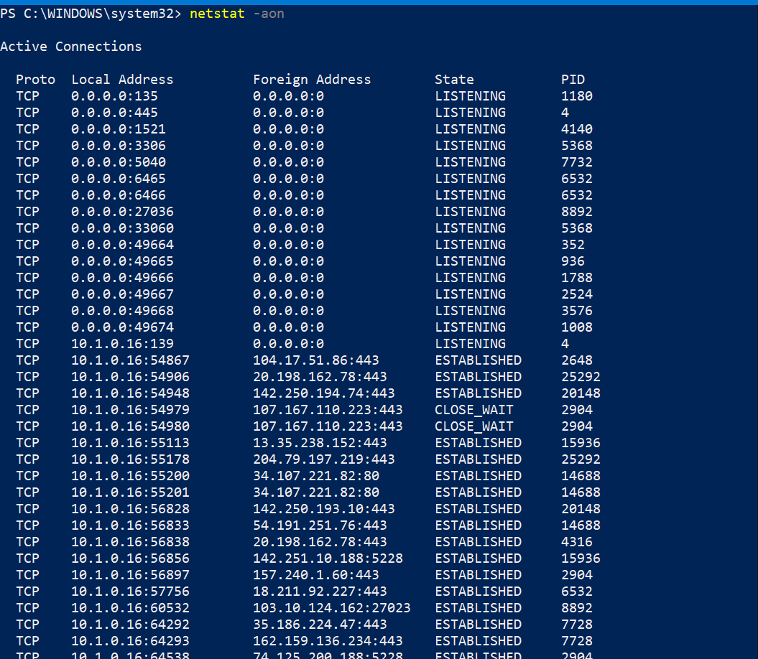

As you can see we have 5 columns.
Proto: This is the base protocol being used (TCP/UDP)
Local address: This is the IP address and Port number (separated by a colon) of your computer being
used to communicate.
Now you can see that in the screenshot, we have various IP addresses: 0.0.0.0 , 10.0.75.1 , 127.0.0.1
This IP address tells you which network is this entry for. For example, if you are connected via LAN
cable and get the IP 192.168.12.123, then all communications via the LAN cable will have this IP.
Parallelly, if you also have WiFi connected with the IP address 10.0.0.145 then for WiFi connections,
this IP will be shown.

Also, 0.0.0.0 simply means all interfaces, be it Local, LAN, WiFi etc. And 127.0.0.1 means
communication is happening locally within your own computer between different applications.
Foreign Address: This is the address of the device your system is communicating with. So let’s say
you visit Google.com on port 443 and Google’s IP address is 1.2.3.4 then in the foreign address, you
will see 1.2.3.4:443 and in the local address, you will see the IP address of the network interface
being used to connect to Google (Like your LAN IP or your WiFi IP etc)
State: This is a very important column as it tells you the state of the connection. In the above
screenshot, you can see ‘Listening’, which means your system is waiting for a connection on the given
port. Similarly, ‘Established’ means a connection has already been made and communication is
probably happening.
PID: This is the process ID of the software handling the communication. You can use ‘tasklist’
command to see all running programs and their respective process ID.
Now let us break down the 1st entry in the output
Here the Protocol is TCP
As the state is listening, and the local address is 0.0.0.0:135 it means that our computer is waiting for
connections on port 135 and 0.0.0.0 means from anywhere, so anyone in your network whether WiFi,
LAN or from your own computer, can connect to your IP on port 135.
In listening, the foreign address doesn't matter too much.
The PID here is 1080.
Below is the output of tasklist command showing what exactly is 1080.

So this means that svchost.exe is listening on port 135 for incoming connections from anywhere
(0.0.0.0)

Now your task was to find open ports on your computer which are waiting for connections i.e.state is
Listening.
From the 1st screenshot, we can see that our system is listening for connections on the following
ports:
135, 445, 903, 913, 1536, 1537 and many more (you might have more or less ports)
You can search about these ports on Google to see what they are used for and why your system is
waiting for the connection.
For example, the port 135 is used by an internal Windows Service responsible for your system to
communicate with other Windows machines in the network for file sharing, authentication, etc.
Same is for 445.

